1. Use Case Diagram:

 

Admin Student

1. Class Diagram:

Library Management System

Username

Password

Login()

Register()

Logout()

Library database

List_of_books

Add()

Delete()

Update()

Display()

Search()

Librarian

Name

Id

Password

Search

Verify_librarian()

Search()

Book

Title

Author

Publication

Show_status()

Reservation_status()

Book_request()

User

Name

Id

Verify()

Check Account()

Get_book_info()

vv

staff

student

Account

No_borrowed_books

No_returned_books

Fine_amount

Calculate_fine()

1. Sequence Diagram:

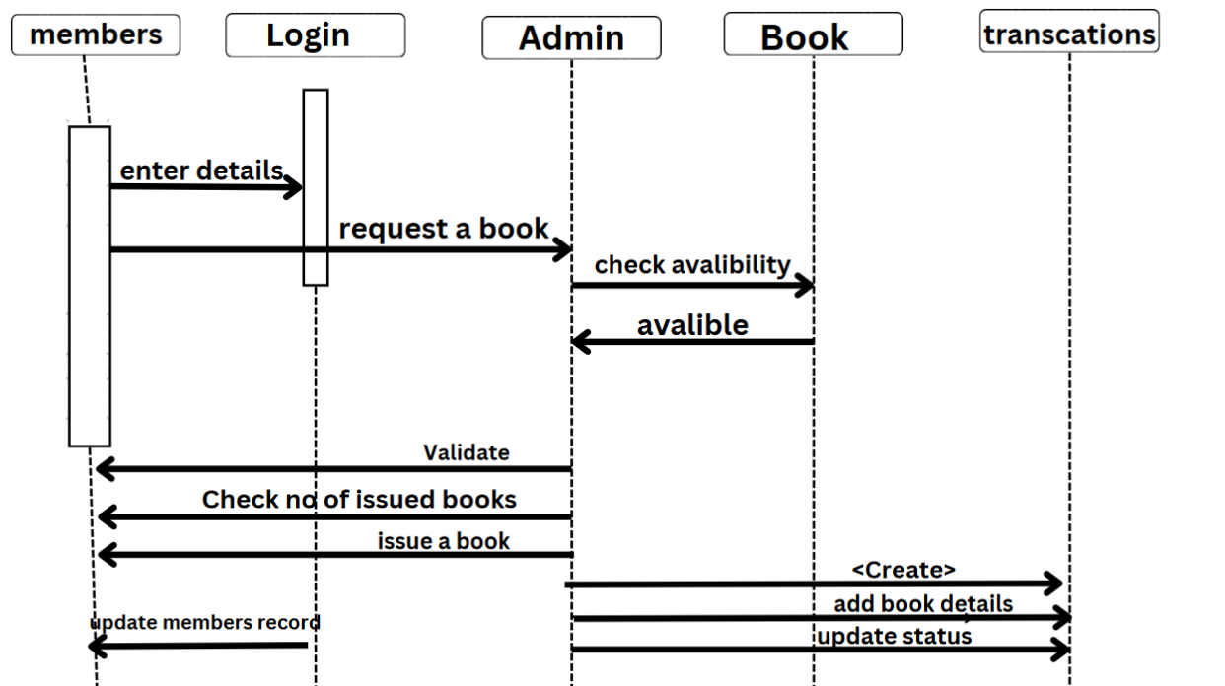

1. Component Diagram:

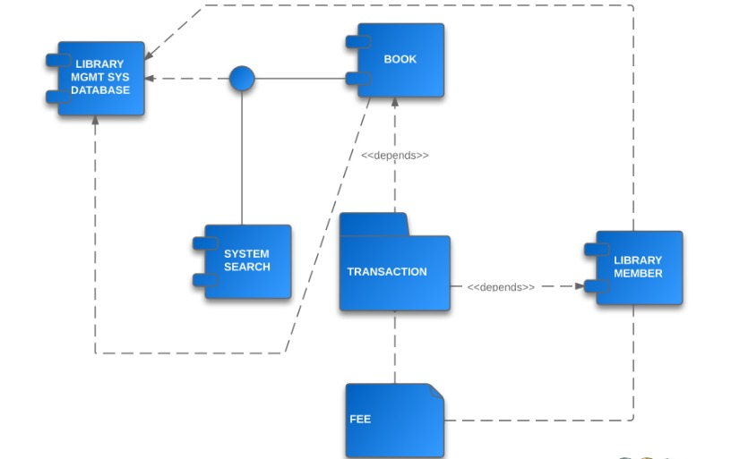

1. Data Flow Diagram:

Level 0:

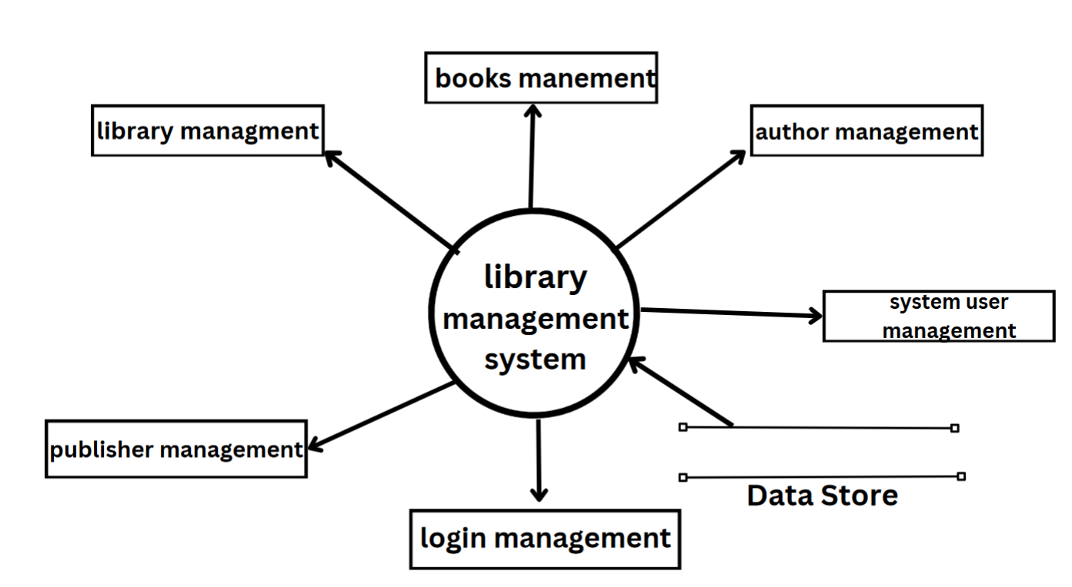

Level 1:

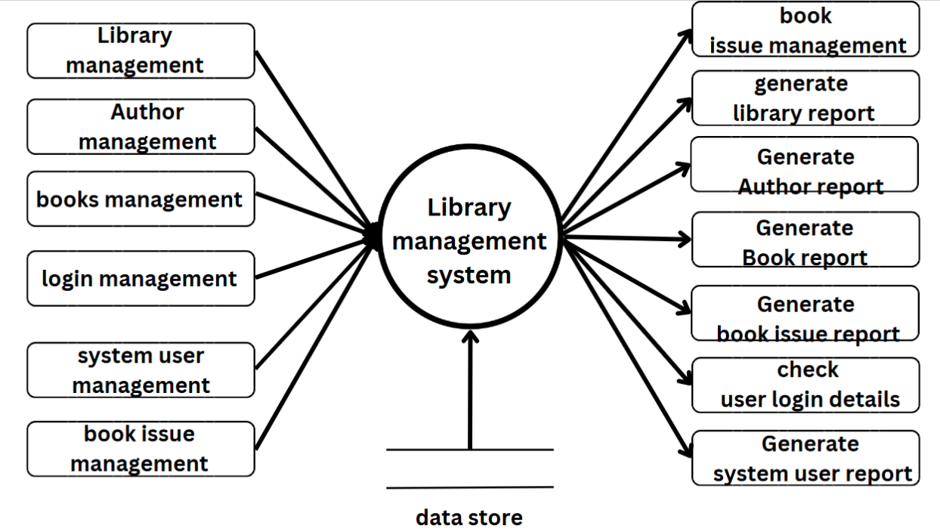

Level 2:

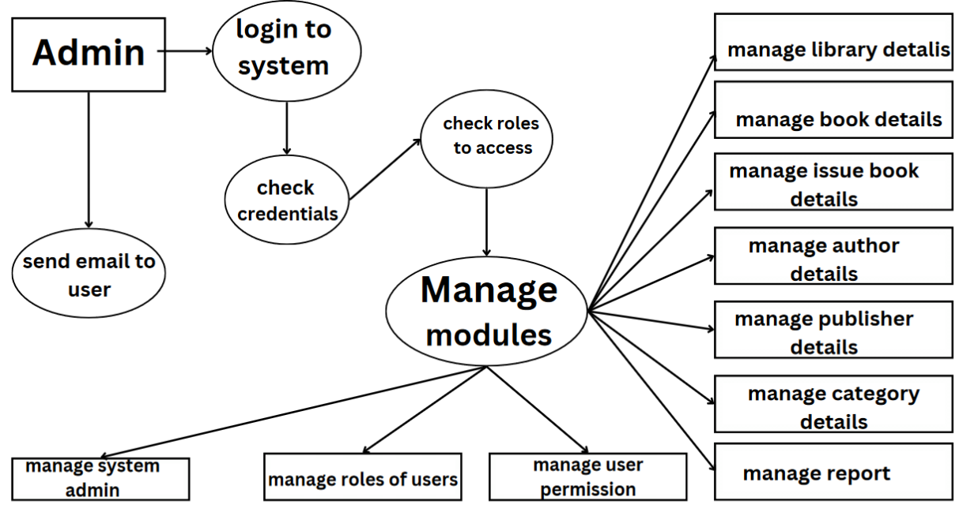

1. Test Cases:

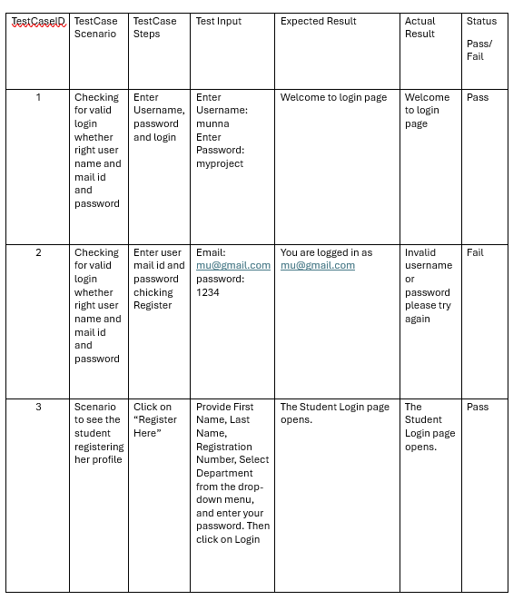

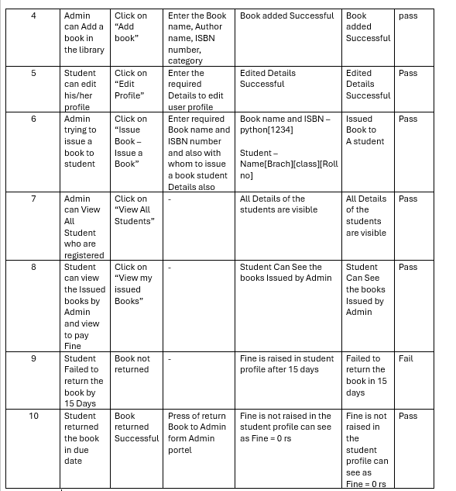

1. Entity-Relationship (E-R) Diagrams:

